**NAME:** **SURNAME:**

**A. Kelimeleri uygun resmin altına yazınız. (12X2=24)**

**1.egg 2.cereal 3.honey 4.muffin 5.sausages 6.croissants 7.olives 8.jam**

**9.cheese 10.bread 11.coffee 12.milk**

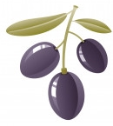[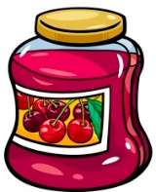](http://www.egitimhane.com)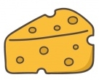

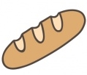

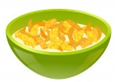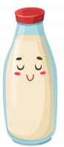 ……………… ……………….. …………………….. …………………….. ……………………… ……………………..

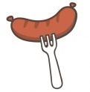[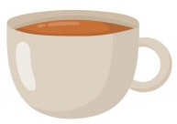](http://www.egitimhane.com)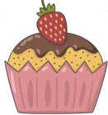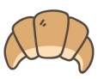

………………… …………………….. ………………... ………………………… …………………… …………………..

**B. Resimlere göre cümleleri yazınız. (6X3=18)**

 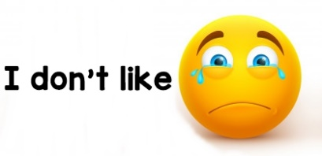

1. 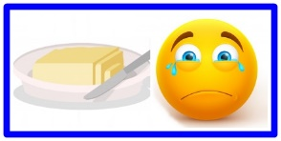…………………………………………………………………………………….
2. 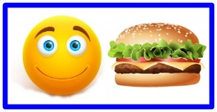……………………………………………………………………………………..
3. 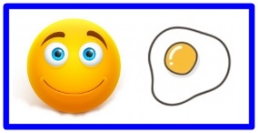……………………………………………………………………………………..
4. 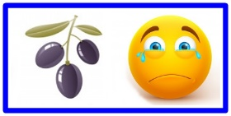……………………………………………………………………………………..
5. 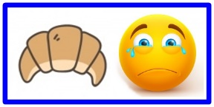………………………………………………………………………………………
6. 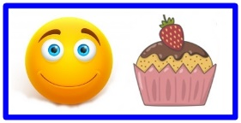……………………………………………………………………………………..

**C. Saatleri yazınız (11X2=22)**

**a. 11.00** : ……………………………………………………………………..

**b. 07:30** : ……………………………………………………………………..

**c. 10:20** : ……………………………………………………………………..

**d. 05:00 : …………………………………………………………………..**

**e. 08.45 : …………………………………………………………………..**

**f. 07:55 : ……………………………………………………………………**

**g. 08:40 : …………………………………………………………………..**

**h. 12.00 : …………………………………………………………………...**

**i. 02:45 : …………………………………………………………………….**

**j. 01:00: …………………………………………………………………….**

**k. 04:50: ……………………………………………………………………**

|  |
| --- |
| **a. farm b.feed the animal c.town d.kiosk e.downtown**  **f. traffic jam g. skyscraper** |

**D. Kelimeleri resimlerle eşleştiriniz. (7X3=21)**

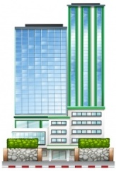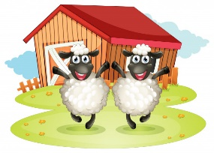 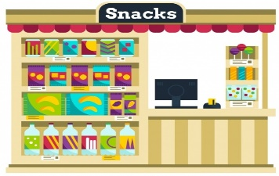 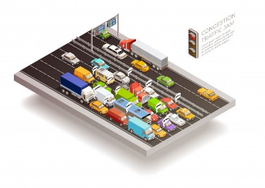

………………………........ ………………………………… ………………………………….. ..……………………………….

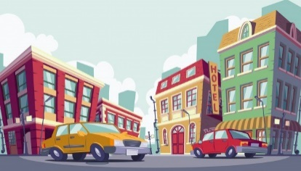 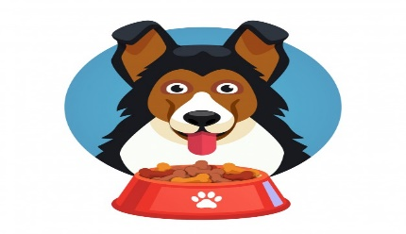 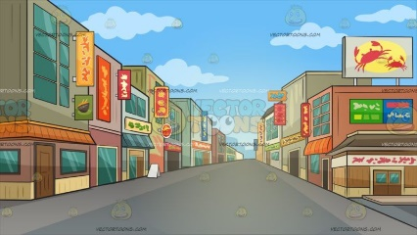

…………………………………………… ………………………………………………. …………………………………………………

**E. Karşılaştırma cümlelerini tamamlayınız (5X3=15)**

**1.** BMW is **(expensive)** …………………………………………… Fiat

**2.** Hadise is **(beautiful) ……………………………………………………………………** Seda Sayan

**3.** Rabbit is **(fast) ……………………………………………………………** tortoise

**4.** Istanbul is **(crowded)** ………………………………………………………… Bursa.

**5.** Konya is **(large)** …………………………………………………………………… İzmir